ENHANCED PROFESSIONAL STUDENT LOGBOOK

BIT4107 – MOBILE APPLICATION DEVELOPMENT

STUDENT NAME: KARAKACHA JACKSON WAMBOYE

Admission Number: BIT/2018/85515

SCHOOL/FACULTY: SCHOOL OF COMPUTING AND INFORMATICS, DEPART. OF

INFORMATION TECHNOLGY

PROGRAMME: Bachelor of Science in IT

ACADEMIC YEAR: 2025/2026

SEMESTER: MAY”AUG 2026

LECTURER: LECTUER NYORO MICHEAL

PHONE NUMBER: [Lecturer's Phone]

Instructions

This logbook is used to document weekly learning activities, practical exercises, skills acquired, challenges encountered, solutions applied, and reflections. Students should complete all sections every week. Each week is to follow the format and remarks in Week 1 section.
Semester Project Tracking
Project Title: RAVITEC STUDENT MANAGEMENT INFORMATION SYSTEM
Project Objectives
- To provide a mobile platform for log into the system, register students and view details.
- To enable members (registered members) to log in to the system, view results and check fee payments from their digital device.
- To digitize member communication and notification of dividend declarations.
- To reduce physical traffic to the offices by providing self-service options.
- To provide a secure and user-friendly interface for information access.

Project Requirements
Functional:
- User Authentication: Login and Registration for members.
- Dashboard: Display information summary (student information, fees, and results).
- Member Profile: View and edit personal details.
- Residential Application: Apply for a course and view status.
- Transaction History: View personal information. fees and results
Non-Functional:
- Security: Data encrypted; use HTTPS and secure authentication.
- Usability: Intuitive and responsive UI for mobile.

- Performance: Fast loading times, even on slower networks.
- Offline Capability: Basic functionalities like viewing cached account info.

Key Features Implemented

1. Authentication System
- Firebase Authentication for secure login/registration
- Session management with Shared Preferences
- Form validation with custom validators

2. Local Storage (SQLite)
- Offline data caching
- CRUD operations for users, students, courses, and transactions
- Data persistence across app restarts

3. API Integration
- REST API calls with error handling
- Graceful handling of 404 and 500 errors
- Connectivity checks

4. UI/UX
- Responsive design with Material Design principles
- Smooth navigation between screens
- Loading states and error handling

5. Push Notifications
- Firebase Cloud Messaging integration
- Local notifications support
- Background message handling

6. Security
- HTTPS for all API calls
- Secure Firebase authentication
- Data encryption with Firestore

Development Milestones
- Week 1-3: Project setup, environment config, UI wireframing in Figma, core screens.
- Week 4: Implementation of local data storage (Shared Preferences, SQLite).
- Week 5: API integration to fetch user data and account details.
- Week 6-7: Implementation of core features (student registration, Profile).
- Week 8: Project planning and finalization of feature set for MVP.
- Week 9: Integration of device features (e.g., Camera for document upload).
- Week 10: Implementation of push notifications via FCM.
- Week 11: Security hardening, code obfuscation, input validation.
- Week 12: Rigorous testing on multiple devices and emulators.
- Week 13: Build deployment (APK/AAB) and documentation.
- Week 14: Final project presentation and demo.

Week 1: Introduction to Mobile Application Development
Practical Activities Undertaken:
- Researched and compared current IDEs for mobile development (Android Studio, Xcode, VS Code).
- Successfully installed and configured development tools: Android Studio, Flutter SDK, Git, Java JDK.
- Ran flutter doctor and fixed all environment errors.
- Created first Flutter project (firstapp) and ran it on the Android emulator.
- Modified the default app to change background color and app title.

Screenshots/Evidence Attached: Yes

FIG 1 SOFTWARE DOWNLOAD AND INSTALATION.
Android studio
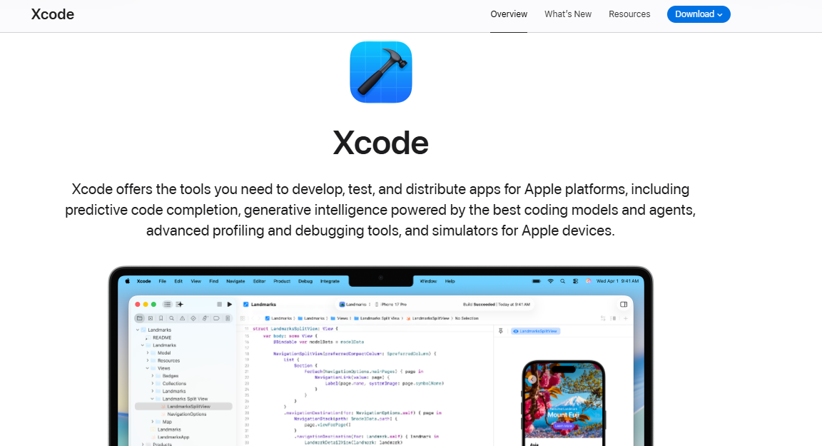

Xcode download

Android SDK TOOLS

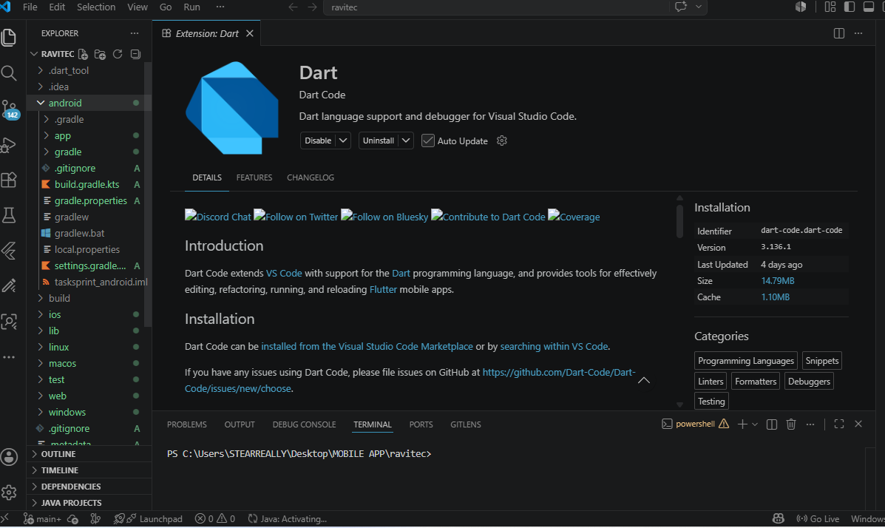

Dart in VS CODE

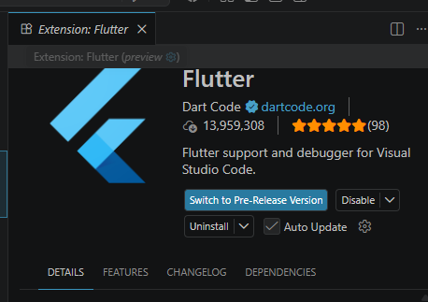
Figure 6

-Since GitHub Copilot is deprecated, we will use the chat
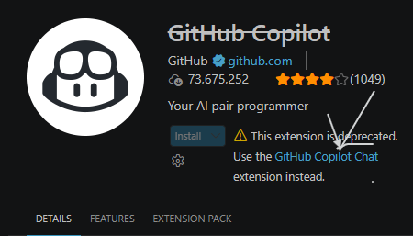

Tools/Software Used: Android Studio, VS Code, Flutter SDK, Git, Android Emulator

Personal Reflection: Setting up the environment was time-consuming but straightforward. Understanding the role of different tools like the IDE and SDK Manager is crucial. Successfully running the first app was a rewarding first step.

Week 2: Mobile Development Environment

Practical Activities Undertaken:
- Practiced syntax in Kotlin and Dart, focusing on variables, functions, and classes.
- Explored UI component libraries in Flutter by creating a Login Screen prototype.
- Created a Student Registration page with TextFields, Buttons, and validation logic.
- Integrated basic navigation between screens using Flutter's Navigator.

Screenshots/Evidence Attached: Yes
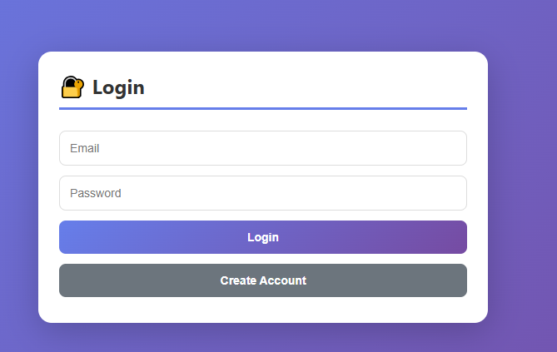
LOG IN SCREEN
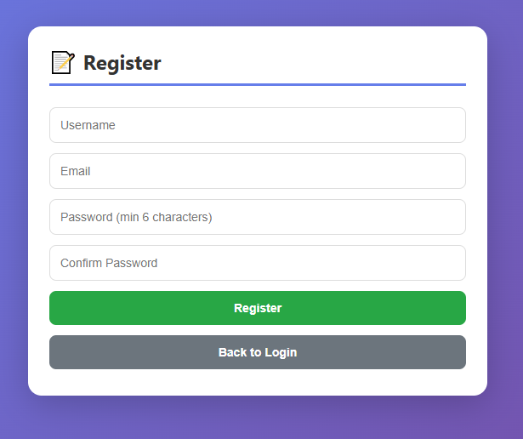

STUDENT REGISTRATION FORM.

Tools/Software Used: Flutter SDK, VS Code with Flutter/Dart Extensions,

Personal Reflection: Dart's syntax is familiar, and Flutter's widget-based architecture is intuitive. I encountered errors with state management when handling TextFields, but applying theTextEditingController solved the issue effectively.
Week 3: User Interface Design
Practical Activities Undertaken:
Designed UI/UX flow for student management information system app.
Created wireframes and high-fidelity mockups for Login, Registration, Dashboard, and Profile screens.
- Converted Figma designs into actual Flutter code.
- Implemented responsive layout using MediaQuery and Expanded widgets.
Screenshots/Evidence Attached: Yes

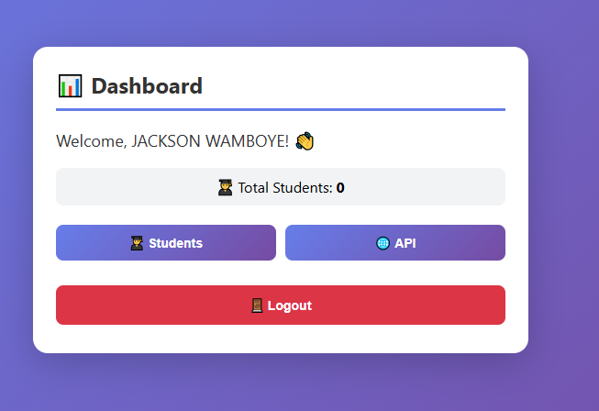

Tools/Software Used: Figma, Flutter SDK, VS Code, Flutter DevTools

Personal Reflection: UI design is a critical skill. Figma made it easy to prototype and visualize the user journey. Translating design to code highlighted the importance of precision in layout and component placement.

Week 4: Event Handling and User Interaction
Practical Activities Undertaken:
- Implemented event handlers for button clicks (e.g., Login button).
- Added form validation logic to the Login and Registration screens.
- Used Gesture Detector for custom gestures like tapping on a profile picture.
- Used FutureBuilder to manage asynchronous tasks with loading indicators.
- Implemented app state management using the Provider package.

Screenshots/Evidence Attached: Yes

Log in page
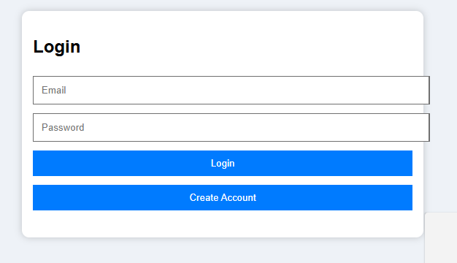

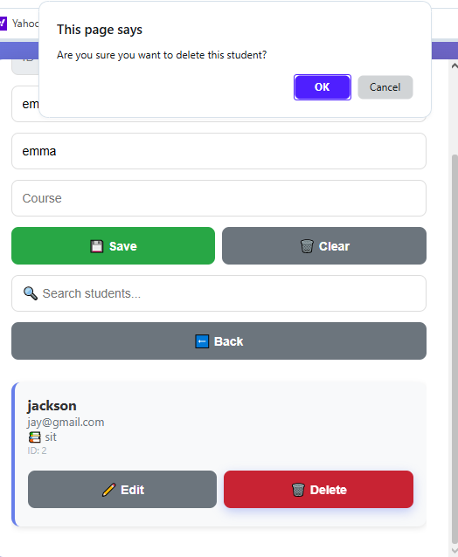
Interactive page

Tools/Software Used: Flutter SDK, VS Code, Provider package, Android Emulator

Personal Reflection: Understanding event handling is fundamental for creating interactive apps. Form validation is a crucial feature to ensure data integrity and provide a good user experience.
Week 5: Data Management
Practical Activities Undertaken:
- Implemented local storage using Shared Preferences to save login status and preferences.
- Created a SQLite database to cache user records locally.
- Wrote SQL commands to create tables and perform CRUD operations.
- Developed a "Student Registration Application" that stores and displays student records.
- Implemented a ListView to efficiently display a list of stored users.
THE APPLICATION RUNS ON THE BROWSER
THIS MEANS WE RUN THE TERMINAL TO ENABLE STORE AND FETCH DATA FOR THE USER OF THE SYSTEM.

Screenshots/Evidence Attached: Yes
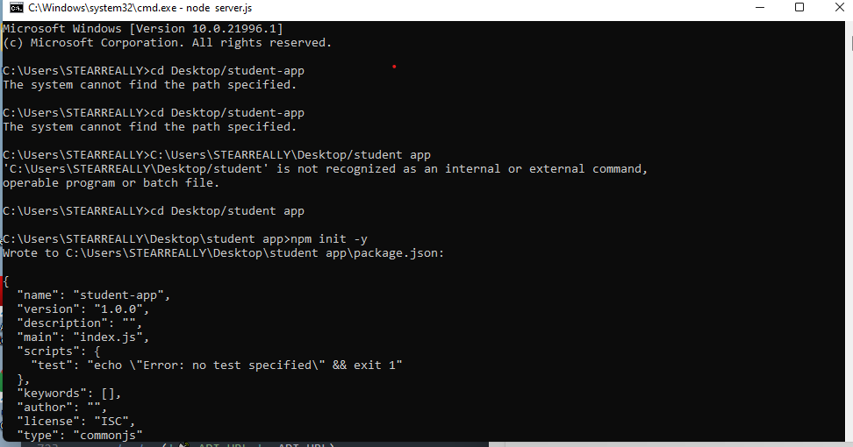

Windows command line 1
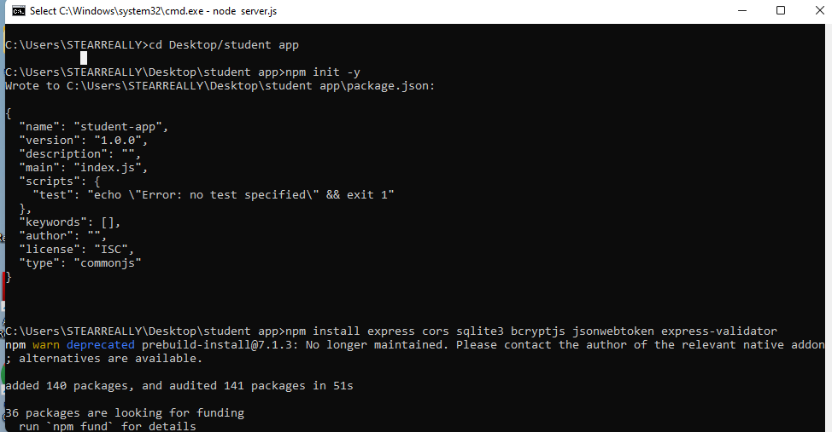

Windows command line 2

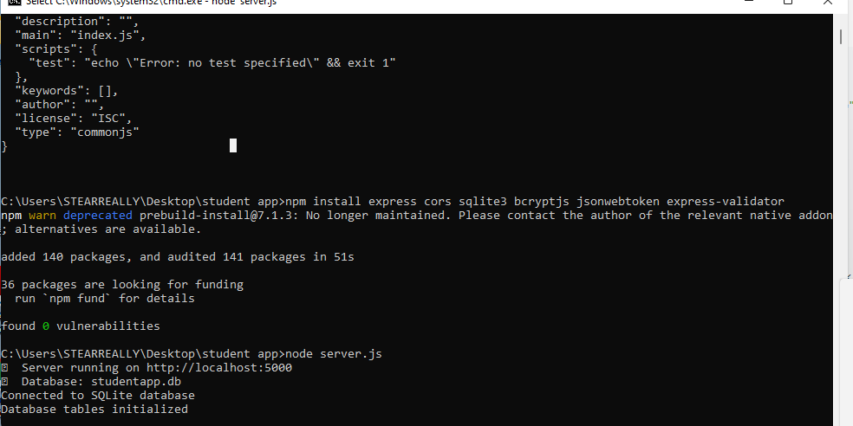

Windows command line 3

Tools/Software Used: Flutter SDK, SQLite package, shared_preferences package, Android Studio

Features
- Secure Authentication - JWT tokens with crypt password hashing
- SQLite Database - Lightweight, file-based database
- Full CRUD Operations - Create, Read, Update, Delete students
- Search Functionality - Search students by name, email, or course
- User-Specific Data - Each user sees only their own data
- Session Persistence - Token stored in local Storage
- Beautiful UI - Modern gradient design with smooth animations
- Error Handling - Proper validation and error messages
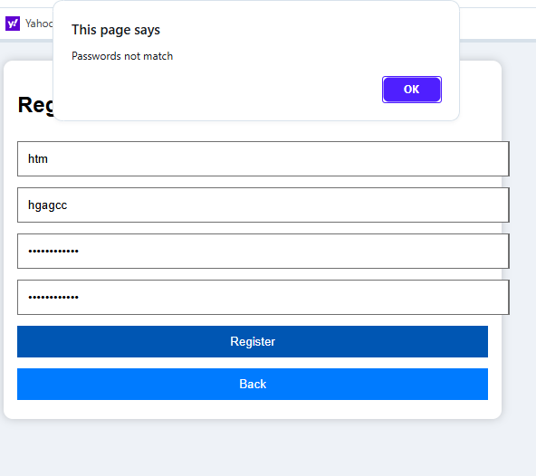
Form Validation

Personal Reflection: Data persistence is crucial for building functional apps. SQLite is powerful for structured data, while Shared Preferences is perfect for simple key-value pairs. The SQLite package makes database interactions straightforward.

Week 6: Networking and APIs
Practical Activities Undertaken:
- Researched and understood REST APIs and JSON.
- Made HTTP GET requests to a public API (JSONPlaceholder) using the http package.
- Parsed JSON response and converted data into Dart objects using from Json.
- Displayed retrieved data in a ListView widget.
- Implemented error handling for network requests, showing Snack bar for 404 or timeout errors.

- Register a new account
- Login with your email and password
- Add students (they'll save to the database)
- Search for students
- Edit and Delete students
- See the API section fetch data from an external API

Screenshots/Evidence Attached: Yes

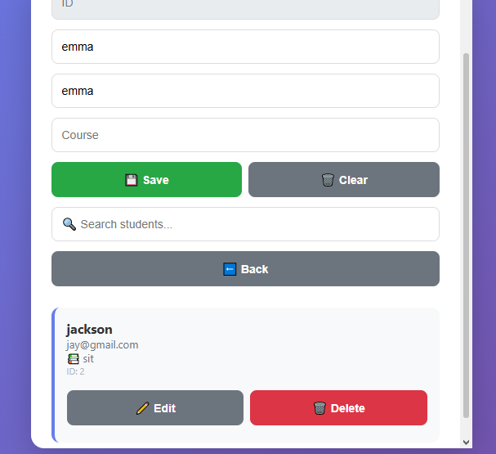
Edit student information.

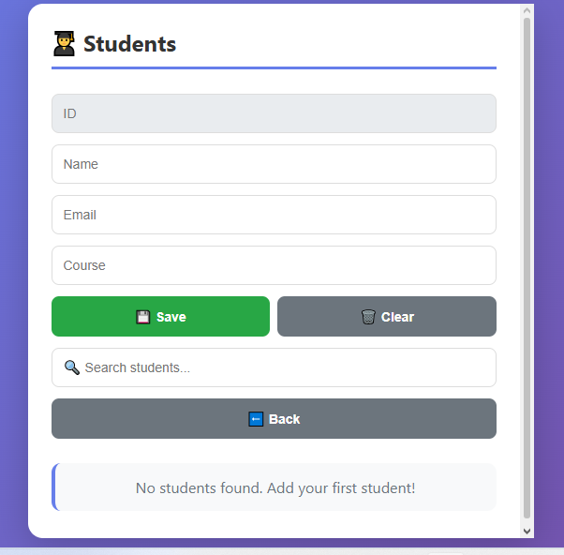
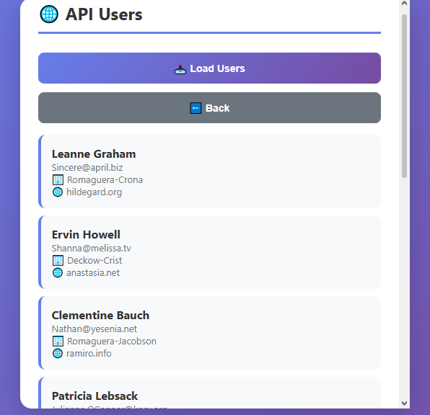
API DISPLAY

Tools/Software Used: Flutter SDK, http package, JSON Placeholder API, VS Code

Personal Reflection: Networking is a game-changer. This week proved how apps can become "live" by communicating with servers. Understanding asynchronous processing is key to keeping the UI responsive.
Week 7: Application Architecture
Practical Activities Undertaken:
- Designed MVVM architecture for the project to separate concerns.
- Created distinct folders for models, view models, views, and services.
- Refactored existing code to follow this architectural pattern.
- Implemented a Services folder to handle API calls and database operations.

Screenshots/Evidence Attached: Yes


Log in page
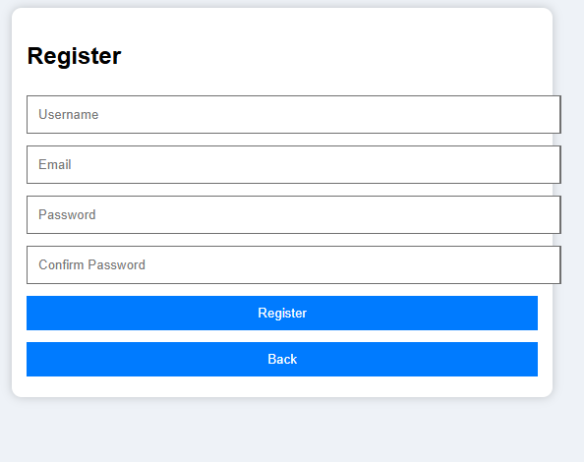
Registration






Add student information

Tools/Software Used: VS Code, Flutter SDK, Provider package

Personal Reflection: A good application architecture makes the codebase more maintainable, scalable, and easier for team collaboration. Separating the UI logic from business logic is a crucial professional practice.

